

|  |  |
| --- | --- |
| **Name** | **Komal Fawad**  **Maham Iftikhar** |
| **Subject** | **OOPS** |
| **Assignment#3** | **Messaging App** |
| **Roll no.** | **SP24-BSE-053(B)**  **SP24-BSE-056(B)** |

**SUBMITTED TO:**

**Sir Muhammad Shahid Bhatti**

**Messaging App**

Introduction:

This messaging app is a console-based application which implements socket programming concepts. It involves server and client communication which connect with each other through IP address. Following images show its working:

Server:

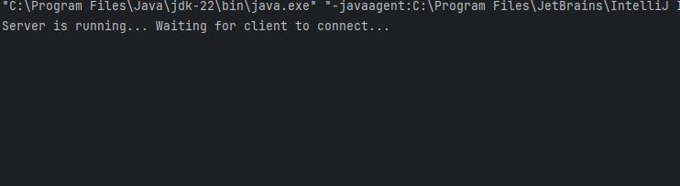

Client:

After entering the IP address both server and client will connect with each other and be ready to communicate.

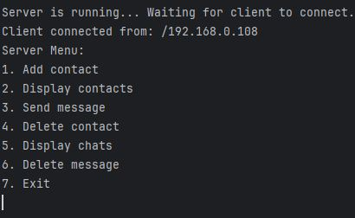

* **Classes:**
* Contact class
* Sms class
* MessageApp class
* Server class
* Client class
* **Methods:**
* Add contact (to add contact in contact array)
* Display contacts (to display all the contacts)
* Display Messages (to display all chats)
* Send message (to send messages to receiver)
* Delete message (to delete messages by ID)

Screenshots of outputs:

1. **Send message:**

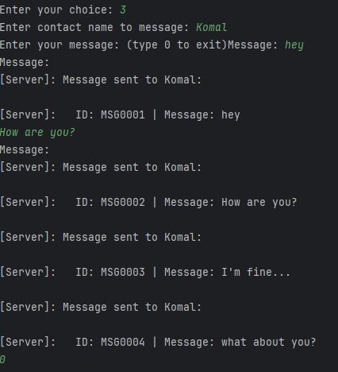

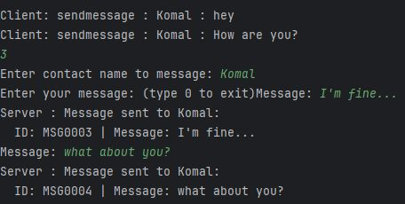

1. **Display Chats:**

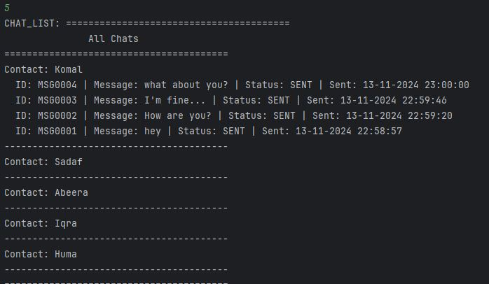

1. **Display Contact:**

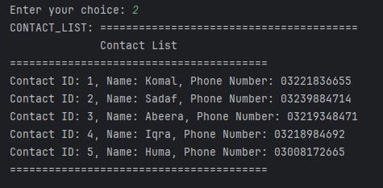

1. **Add Contact:**

1. **Delete Message:**

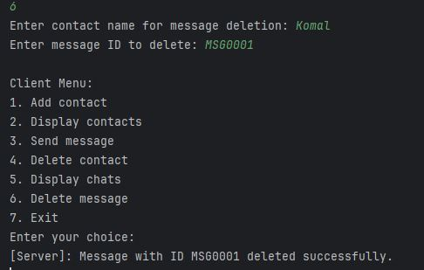

**UML Diagrams:**



